Version No: 0.A DD Month YYYY
Copy: electronic

Business Resource Efficiency Program Waste Audit Report [COMPANY NAME]
Prepared by

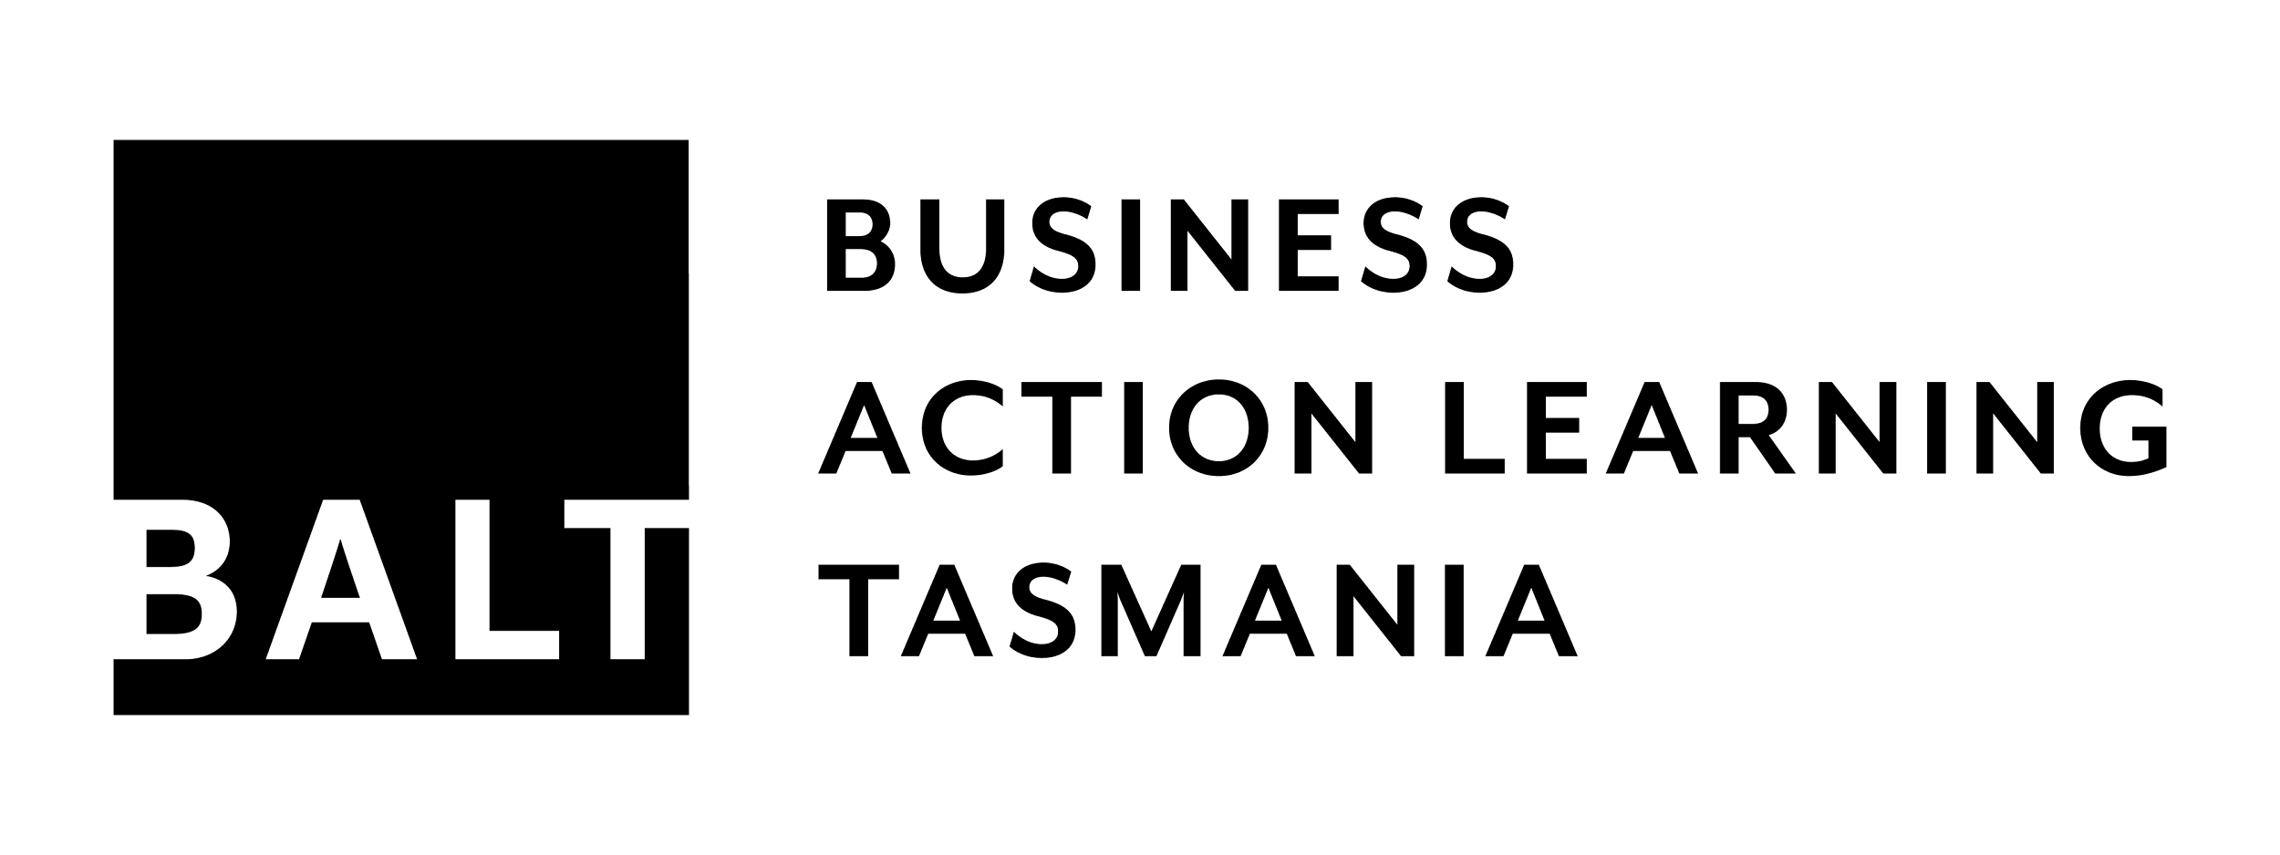
The Business Resource Efficiency Program is a partnership between the Tasmanian Government
and Business Action Learning Tasmania and is funded by the Tasmanian Government.
BREP Waste Audit Report Template with Guidelines © 2018 by Genevieve Cother is licensed under Attribution-ShareAlike 4.0 International. To view a copy of this license, visit http://creativecommons.org/licenses/by-sa/4.0/

Executive summary
The Business Resource Efficiency Program (BREP) is a key action of Climate Action 21: Tasmania’s Climate Change Action Plan 2017-2021 (Climate Action 21) and will assist small and medium-sized enterprises (SMEs) to improve resource efficiency, reduce waste and operating costs, and drive productivity gains.
The audit assessed the resource efficiency of operations at the [location] premises of [Company name] (the Company).
The scope of the site waste survey includes the geographical boundaries of the Company site and all operations within those boundaries.
The scope of the process audit is limited to major processes and equipment on-site. All value-adding steps, conducted within the site boundaries, will be included. Product lifecycle is considered, including procurement, design processes, manufacturing, packaging and distribution, and end-of-life scenarios.
The objectives of the audit are to:
- Identify opportunities to reduce resource usage throughout the value chain and/or product lifecycle.
- Identify opportunities to avoid, re-use, or recycle waste streams.
Findings made during the audit have been analysed using industry benchmarks and known best practice, legislative and regulatory requirements, lifecycle thinking, and application of the waste management hierarchy.

Summary of findings
[x] Observations have been made during the audit, with [x] recommendations for improved resource efficiency. One or more of these could be considered as the subject of an action learning project, or action could be taken immediately, where possible.

Summary of recommendations

CONTENTS

Introduction 4
Objectives of the audit 4
Scope of the audit 4
Criteria for assessment 4
Description of findings 4
Methodology 6
Questionnaire 6
Interview 6
Desktop audit 6
Site audit 6
Analysis 6
Limitations 6
Background and context 7
Audit findings 8
Observations 8
Waste survey report 8
Analysis 9
Industry benchmarks and known best practice 9
Legislative requirements and international standards 9
Lifecycle thinking 9
Application of the waste management hierarchy 10
Recommendations 12
Appendices 13

Introduction
The Tasmanian Government is committed to growing a climate-ready economy. Through Climate Action 21: Tasmania’s Climate Change Action Plan 2017-2021 (Climate Action 21), the Tasmanian Climate Change Office (TCCO) will work with businesses to:
- reduce emissions intensity;
- adopt innovative practices;
- support businesses to manage climate risks; and
- take advantage of opportunities that may arise from a changing climate.
The Business Resource Efficiency Program (BREP) is a key action of Climate Action 21 and will assist small and medium-sized enterprises (SMEs) to improve resource efficiency, reduce waste and operating costs, and drive productivity gains.
A key deliverable of BREP is a comprehensive waste audit for each participating SME. The audit considers qualitative data, collected through questioning of key personnel and observation of operations, and quantitative data, from a site waste survey, to create a holistic view of resource efficiency opportunities. The analysis of data references industry-specific criteria, and includes a more general assessment using lifecycle thinking and the waste management hierarchy. The results of analysis are presented as a series of recommendations, including the potential to use action learning to realise the opportunities identified.

Objectives of the audit
    - Identify opportunities to reduce resource usage throughout the value chain and/or product lifecycle.
    - Identify opportunities to avoid, re-use, or recycle waste streams.

Scope of the audit
This audit of [Company name] assessed the resource efficiency of operations at its [location] premises. The scope included…
- geographic boundaries
- operational boundaries
- product lifecycle
- value chain

Criteria for assessment
Criteria for assessment of audit findings have been agreed with the participant during a preliminary interview. They include:
- industry benchmarks and known best practice (where they exist)
- legislative requirements and international standards
- lifecycle thinking
- waste management hierarchy

Description of findings
Audit findings are reported as Observations (Obs):
- Observations may be negative or positive.
- They may be issues identified that the organisation could consider addressing immediately, eg. breaches of legislative requirements, environmental hazards, or ‘low hanging fruit’.
- They may be demonstrations of best practice that could be replicated across other areas of the organisation, or used as examples from which other organisations can learn.
- They may support or highlight a systemic issue or barriers to growth that will benefit from fresh eyes, collaboration or organisational learning to find new ways of doing things.
The Observations are recorded in Section 4 and analysed against the criteria above in Section 5. Outcomes of analysis are reflected in the recommendations put forward in Section 6.

Methodology

Questionnaire
A Company Profile questionnaire has been completed by the participant to provide context for the organisation and inform the scope of the audit. The industry sector, main products and processes, and any specific regulatory requirements have been identified. This provided direction for the auditor to access relevant information and available data for the desktop audit and industry benchmarking.

Interview
An interview has been conducted with [name] on [date] to agree upon the audit objectives, establish the scope and criteria of the audit, and prepare for the desktop and site audits.

Desktop audit
A desktop audit has been conducted [date] and documents reviewed are listed in Appendix 7.1.

Site audit
A site audit of the organisation’s [location] premises has been conducted on [d Month YYYY] to to map waste and identify opportunities to increase resource efficiency across operations.
An Audit Checklist and Waste Survey Worksheets have been completed for business functions within the scope of audit. Findings are summarised in Section 4.

Analysis
Observations made have been analysed using…
List specific references for industry benchmarks and known best practice, legislative and regulatory requirements, lifecycle thinking and application of the waste management hierarchy.

Limitations
Describe specific limitations to methodology, eg. data, criteria and/or analysis

Background and context
Summary of:
- Company and site history
- Company structure
- Site map
Summary of:
- Industry sector
- Main products and processes
- Direct competitors
- Main suppliers
- Significant equipment
- Regulatory environment

Audit findings

Observations
Obs1 | ...
Obs2 | ...
Obs3 | ...

Waste survey report
[Generated by Bin Trim Tool]

Analysis

Industry benchmarks and known best practice
    - Applicable benchmarks and best practice
The industry associations subscribed to by the Company do not offer any benchmarks or best practice guidelines for resource efficiency. The Company may choose to seek benchmarks from within the wider manufacturing industry during the action learning program.
In terms of waste minimisation, Lean thinking is considered best practice for any type of manufacturing.
Lean is the continuous quest to maximise value and eliminate waste from production processes. Lean defines seven types of waste (or muda):
1. Overproduction
2. Waiting
3. Unnecessary transporting
4. Inappropriate processing
5. Unnecessary inventory
6. Unnecessary motion
7. Defects
    - Analysis
      - Overproduction

      - Waiting

      - Unnecessary transporting

      - Inappropriate processing

      - Unnecessary inventory

      - Unnecessary motion

      - Defects

    - Conclusions

Legislative requirements and international standards
    - Applicable instruments
- Legislation and regulations
- International and other standards
- Industry specific codes of practice
    - Analysis
[nonconformances]
    - Conclusions
[recommendations]

Lifecycle thinking
    - What is lifecycle thinking?
Resource efficiency considers the lifecycle of a product from manufacture to end-of-life disposal. The term resource encompasses raw materials, energy resources and all operating supplies required to add value to the product.
Inputs are measured, usually in terms of labour, energy and material use, and outputs are measured in terms of the product itself, the waste created through the process and waste created at end-of-life.
This approach is derived from product lifecycle assessment (LCA) and “closed loop” or “cradle to cradle” systems.
LCA considers all of the inputs and outputs at every stage of the product lifecycle, from raw material extraction to end-of-life disposal, and quantifies environmental impacts using a wide range of metrics such as land disturbance, impacts on flora and fauna, greenhouse gas emissions, etc.
Closed loop systems seek to create separate streams of technical (abiotic or non-organic) material and organic materials. Technical materials are able to be fully recovered and re-manufactured into a product of equal or higher value, and renewable organic materials are composted, thereby ‘closing the loop’ and eliminating the need for virgin materials.
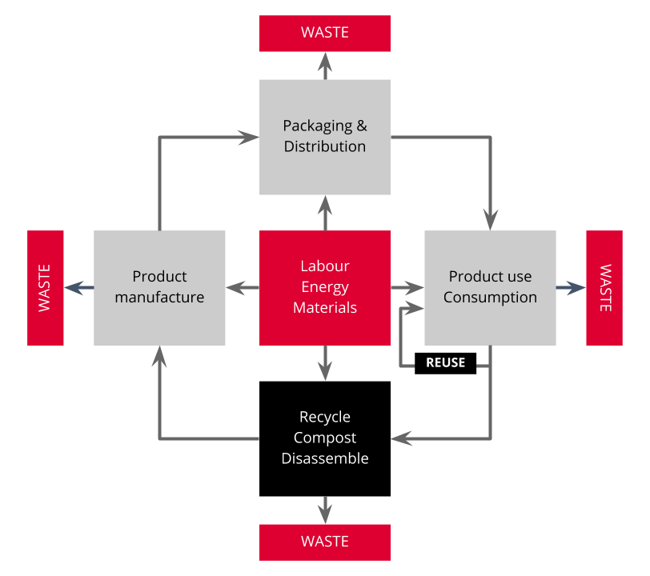Figure 1. Product Lifecycle - Labour, Energy, materials use

    - Analysis
[Product design]
[Procurement]
[Manufacturing]
[Packaging]
[Distribution]
[Use]
[Disposal]
    - Conclusions
[Recommendations]

Application of the waste management hierarchy
    - What is the Waste Management Hierarchy?
EPA Tasmania describe the Waste Management Hierarchy as follows:
“The waste management hierarchy provides an order of preference for implementing waste management options. The primary objective of the waste management hierarchy is to reduce potential hazard to human health and the environment by avoiding or minimising the production of wastes. Secondary objectives include the efficient use and conservation of resources, a reduction in the need for disposal, and improved cost efficiency through reduced waste disposal and material costs.” - EPA Tasmania
The hierarchy is as follows:
- Avoidance
- Reuse
- Recycling
- Energy recovery
- Repository storage (for future treatment/recovery)
- Treatment
- Disposal/permanent containment

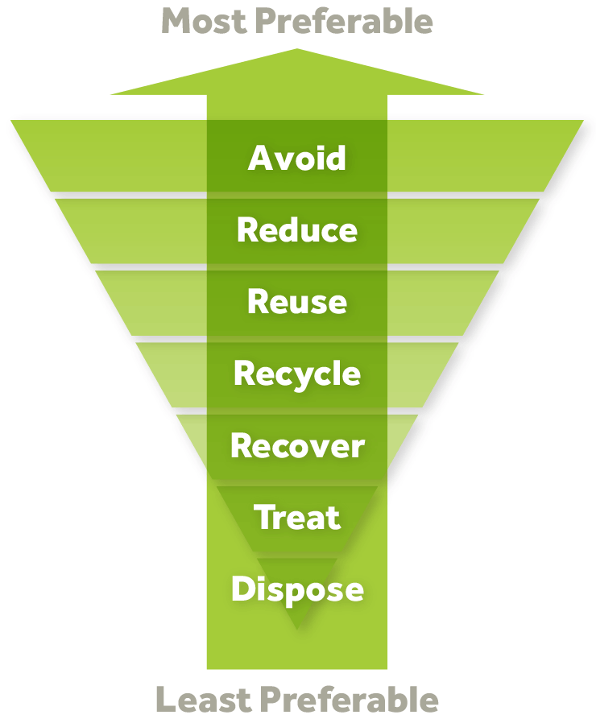
Figure 2. Rethink Waste - Waste Management Hierarchy

    - Analysis
[Avoidance
Reuse
Recycling
Energy recovery
Repository storage (for future treatment/recovery)
Treatment
Disposal/permanent containment]
    - Conclusions
[Recommendations] How can we move up the hierarchy?

Recommendations
  - …
  - …
  - …
  - …

Appendices
  - Documents reviewed

https://epa.tas.gov.au/regulation/waste-management/controlled-waste/controlled-waste-minimisation Accessed 14/8/2018
http://rethinkwaste.com.au/about/ accessed 14/8/2018
Lowell Centre for Sustainable Production - A New Way of Thinking

